Dis**-**ME-Syria, Golan Heights, Berekhat Ram, Venus, 800,000-230,000 BP

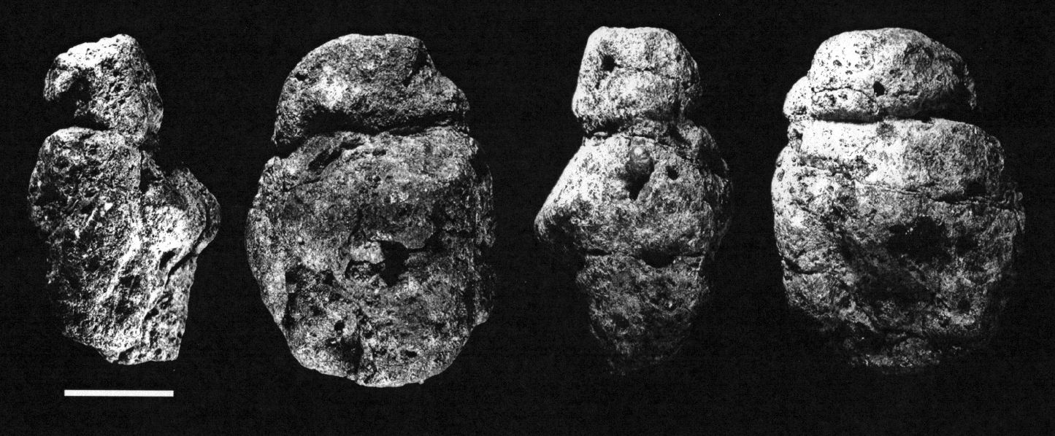 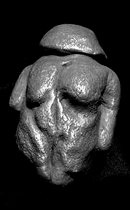

Fig. 1. Left four views of original basalt tuff pebble found at Berekhat Ram, after <http://www.donsmaps.com/images33/berekhatrambwallviews.jpg>.

Fig. 2. Right, resin so-called “replica”.

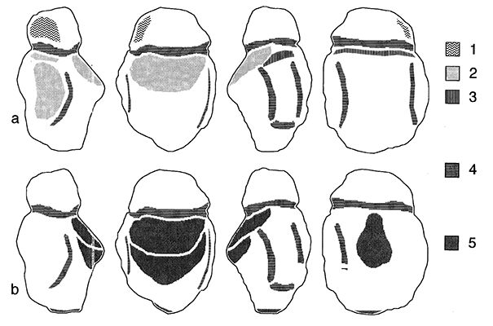

Fig. 3. Anthropogenic modifications on the Berekhat Ram object according (a) to Marshack (1997) and (b) to d'Errico and Nowell (2000):   
  
1: shaping and beveling of the right protuberance of the head  
2: scraping  
3: artificial smoothing of the lower plan of the neck groove  
4: grooving  
5: possible abrasion. From left to right: right side, front face, left side, rear face.

Formal Label: Syria, Golan Heights, Berekhat Ram, Venus, 800,000-230,000 BP

Accession Number:

**LC Classification:** N5460.E35

Date or Time Horizon: 800,000 BP-230,000 BP

Geographical Area: Golan Heights, Syria

Map: After http://www.donsmaps.com/images33/brmap.jpg

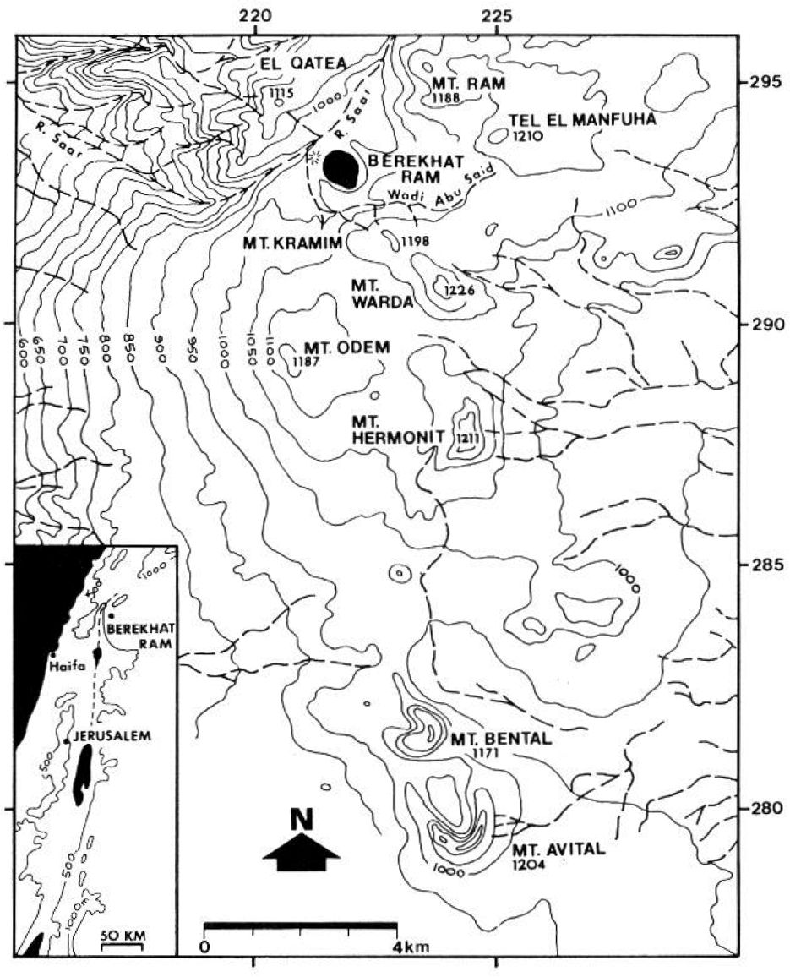

Cultural Affiliation: Acheulian

Medium: Basalt tuff

Dimensions: original, L 35 mm, W 25 mm; T 21 mm

Weight: n/a

Condition: The “replica” in resin is not a true replica at all. Beware.

Provenance: The original basalt tuff pebble was found on the Golan Heights in Syria.

**Discussion:**

This basalt tuff pebble was found by archaeologist N. Goren-Inbar of the Hebrew University of Jerusalem in 1981 in the Levantine area of southern Syria between two layers of volcanic depositions, an upper layer at 230,000 BP and a lower layer at 800,000 BP (Feraud, Hall, Goren-Inbar and Scgwarcz 1983; Belfer-Cohen and Goren-Inbar 1994), which dates it to the Acheulian period (1.5 Mya to 200,000 BP). This assumes the grooves of the pebble around the "neck" and the "arms" (if not natural) appear to define a hominin shape. Alexander Marshack in 1997 analyzed the grooves microscopically and came to a positive conclusion that they were intentional (Marshack 1997; Bahn 1996; Bahn 2000: 44-45). In 1999 Steven Mithen argued that Marshack's analysis did "not demonstrate that the lines are indeed intentional" (Mithen 1999: 152). Then, in 2000 d'Errico, F. and A. Nowell also analyzed the grooves and etchings and found that: “The figurine possesses a number of features that are reminiscent of those produced experimentally by the engraving or abrading the tuff clasts. Intentional engraving seems responsible for the neck groove and the two slightly curved grooves on both sides of the object. A short groove produced by engraving has also been carved on the left side of the rear face. This interpretation is supported by the clear morphological differences, visible at a microscopic scale, between the surface of these grooves and those of the adjacent area. The morphological variability of the groove cross section, however, suggests the use of a point as the tool used, instead of a cutting edge” d'Errico and Nowell (2000). The offered the caveat that it was still "problematic" for modern *Homo sapiens sapiens* to comprehend the intentional shape of a *hominin* body in such an alien cognitive and cultural context as that of *Homo erectus* (d'Errico and Nowell 2000; Bar-Yosef 1994; Bednarik 1995). However, leaving aside modern cognitive biases, we know that northern Syria was actively exploited by *Homo erectus* in the Middle Acheulian as Clark, Eggers and Heinzel [1966] and Goren-Inbar (1985) have shown, so the likelihood of an attribution of this pebble having been worked into a hominin shape by *Homo erect*us is possible if not probable.

**References:**

Bahn, Paul. 2000. *A very short introduction to Archaeology*. New York: Oxford University Press.

Bahn, Paul. 1996. “New developments in Pleistocene art,” *Evolutionary Anthropology* 4: 204–15.

Bar-Yosef, O. 1994. “The Lower Paleolithic in the Near East,” *Journal of World Prehistory* 8: 211–65.

Bednarik, R. G. 1995. “Concept-mediated marking in the Lower Paleolithic,” *Current Anthropology* 36: 605–34.

Belfer-Cohen, A. and N. Goren-Inbar. 1994. “Cognition and communication in the Levantine Lower Palaeolithic,” *World Archaeology* 26: 144–57.

Clark, J. Desmond, A. V. Eggers and Jean de Heinzel. [1966] *Further excavations (1965) at the Middle Acheulian occupation site at Latamne, northern Syria: general results, definitions and interpretation*. [Damas] : [Direction générale des antiquités et des musées]. Offprint from *Annales archéologiques arabes syriennes*, 16: [31]-74.

d'Errico, F. and A. Nowell. 2000. "A new look at the Berekhat Ram figurine: implications for the origins of symbolism", *Cambridge Archaeological Journal* **10**, 123-67.

Feraud, G., D. York, C. Hall, N. Goren-Inbar, and H. Scgwarcz. 1983 “40Ar/39Ar age limit for an Acheulian site in Israel,” *Nature*, 304: 263 – 265.

Goren-Inbar, N. 1985. “The lithic assemblages of Berekhat Ram Acheulean site, Golan Heights,” *Paléorient*, 11, 7 – 28.

Marshack, A. 1997. “The Berekhat Ram figurine: a late Acheulian carving from the Middle East,” *Antiquity*, 71(272): 327–337.

Mithen, Steven. 1999. In Robin Ian MacDonald Dunbar, Chris Knight, Camilla Power, *The evolution of culture: an interdisciplinary view.* Edinburgh University Press